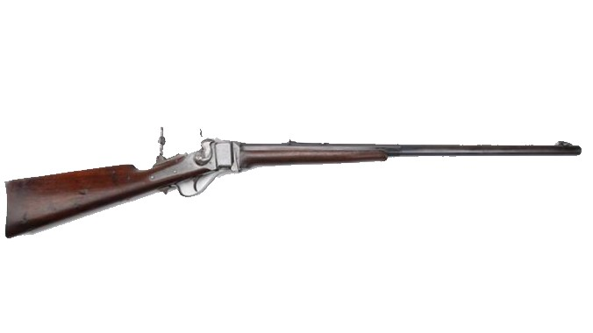

Colorado Gun Collectors Association

Dear CGCA Members,

Our next meeting will be March 21, at the American Legion Post 1 7:00 PM.
For our program, John Kelley will do a presentation on 1911’s.

The NRA is having their annual convention in Indianapolis, IN on April 14-16, 2023.
If anyone would be interested in having a display representing the CGCA, please
contact Les Palmer, contact information is below.

We are gearing up for our annual gun show in May. This year, we are having our
show at the Island Grove Event Center in Greeley. May 19-21, 2023. We are
almost sold out. If you would like a table, contact Dave Weddle, contact information
is below. We could also use volunteers beginning May 18-21. If you can volunteer,
contact Scott Anderson. Scott’s phone number is: 303-761-2833.

Mark your calendars:
Trophy Gun Show Sioux Falls, SD March 25 & 26 2023
Colorado Gun Collectors Show May 20 & 21 2023
Wyoming Weapons Collectors Show May 27 & 28 2023

Mel Flanagan passed on December 11,2022 at the age of 96.
Mel was one of the original founders of our club. He was a past
CGCA President. His services were at Fort Logan National Cemetery. His services
were very well attended. The family had a very nice gathering after the services.

Please visit our website at www.CGCA.com for club news and updates.

If you have questions, please contact:
Les Palmer, President 303-912-5012 President@cgca.com
Cindy Jewell, Secretary/treasurer 303-750-5645; sectreas@cgca.com
Dave Weddle, Show Chairman 720-482-0167 CGCAShow@cgca.com

